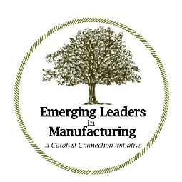

The Catalyst Connection Emerging Leaders in Manufacturing (ELM) Program Cohort 11

Year One Curriculum - 2-day Kick-off Meeting – Thursday & Friday, February 9 & 10, 2023

Continuing seven half-days 8:30 a.m. – 1:30 p.m. on Thursday’s

Thursday, March 9, 2023
Thursday, April 13, 2023
Thursday, May 11, 2023
Thursday, June 8, 2023
Summer break
Thursday, September 14, 2023
Wednesday, October 18, 2023 (note a Wednesday on this date)
Thursday, November 16, 2023

March Workshop – Thursday, March 9, 2023 — Strategy (Peter Drucker)

April Workshop – Thursday, April 13, 2023 - Leadership (Jim Kouzes and Barry Posner) + introduce the summer project (PLDP)

May Workshop – Thursday, May 11, 2023 — Talent (Bill Conaty and Ram Charan)

June Workshop – Thursday, June 8, 2023 — Organizational Culture (Patrick Lencioni) + finalize each participant’s PLDP

Summer semester – With the mentors support, ELM participants will design and initiate implementation of a Personal Leadership Development Plan (PLDP), based on the skills, competencies, tools and approaches presented in the first phase of the ELM program.

September Workshop - Thursday, September 14, 2023 — review participants’ PLDPs

October Workshop - Wednesday, October 18, 2023 — Hiring and Performance Management (Laszlo Bock)

November Workshop – Thursday, November 16, 2023 — Execution Discipline (John Doerr) + 360 Review and preparation for Year 2

