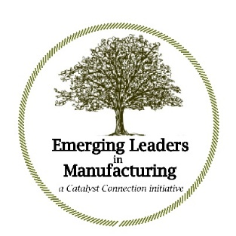

The Emerging Leaders in Manufacturing Program – Cohort 11
Kick-off Agenda: Day One February 9, 2023

8:30 a.m. Introductions and overview of the program, emphasizing:

- The ELM goals, leadership development framework,
Mentor involvement and typical meeting agenda

9:00 a.m. Diagnostics, utilizing the following leadership development tools

- The WPI (Work Personality Index), which will be completed in advance

- Success Profiles, which will be done in-session, with participants and Mentors collaborating

10:45 a.m. Develop and report out on a program Statement of Intent

- With the ELM participant and their Mentor again collaborating
Note: there will be periodic breaks during the day and a full lunch break around noon

1:00 p.m. Complete Report outs on each participant’s Statement of Intent

- ELM program Mentors will be able to leave following this activity

2:00 p.m. Team building exercise

4:00 p.m. Q&A, then adjourn

Note: all times are approximate, as the day will be driven by the participants. We will spend as much time on each area as needed.

The Emerging Leaders in Manufacturing Program
Kick-off Agenda: Day Two February 10, 2023

9:00 a.m. Review of Day One — Questions/Comments

9:30 a.m. Overview of the ELM “Core 4” topics and how we will approach
our work together

- Strategy: The Five Most Important Questions You Will Ever Ask About Your Organization, Peter Drucker

- Leadership: The Leadership Challenge, Jim Kouzes and Barry Posner

- Talent: The Talent Masters, Bill Conaty and Ram Charan

- Organizational Culture: The Advantage, Patrick Lencioni

Note: there will again be periodic breaks during the day and a full lunch break around noon, most likely after introducing the Leadership or Talent module.

2:45 p.m. Review

- Circle back to the intentions for our group, laid out on Day One

- Question/Comments about our approach and plan of action

- Outline our 2021 workshops, discuss additional training opportunities through Catalyst Connection and introduce the Personal Leadership Development Project (PLDP)

4:00 p.m. Adjourn — informal conversation (optional for all participants)

Note: as with Day One, all times are approximate, as the meeting will be driven by the needs and interest of the participants.

