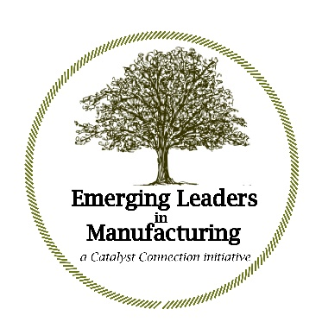
The ELM Participant and Mentor should complete this form together.
Please complete form and send via email to drea@catalystconnection.org by February 3, 2021

Name of ELM participant, current title and years with the company

Name of the Mentor, title and work relationship with the ELM participant

Three leadership strengths the emerging leader can build on and three opportunities for growth and development

Mentor relationship with the ELM participant — please review the end of this document to be clear on the program Mentor role and responsibilities.

Briefly describe the culture and performance of your company

What do you hope to gain from the Emerging Leaders in Manufacturing program (please explain)?

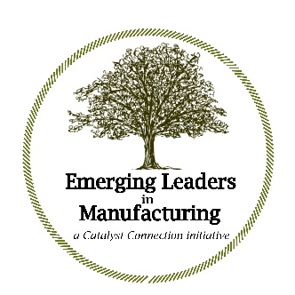

Emerging Leaders in Manufacturing participant-mentor role

Note: the program Mentor’s signature on this form indicates that they accept this critical role, as described below.

- The Mentor should work in close proximity to the ELM participant and be in reasonably regular contact with them
- Both parties should have the utmost respect for one another
- The Mentor is in a position to observe the emerging leader in action and to notice whether behaviors, skills or tactical approaches have changed and improved
- The Mentor should be skilled at giving feedback, good, bad or indifferent, aimed at helping the participant increase situational awareness and improve performance
- The Mentor will periodically engage with Catalyst Connection to help optimize the ELM experience for the participant, the mentor and their company
- This will involve all or some combination of the following:
  - Completing this registration form and agreeing to the ELM Mentor role
  - Attending the Year One (in part) and Year Two (all day) Kick-off meetings
  - Reviewing program e-mail, primarily regarding meeting agendas and outcomes
  - Including agreeing to the mentor-participant collaboration
  - Signing off on four key ELM documents: each of the two summer projects and tool called The Kirkpatrick Model
  - Acting as host company for an ELM meeting (optional), which could include a plant tour and informal sharing of company Best Practices

We have recognized that the role of the ELM Mentor can be very consequential in helping to achieve the aims of the program: individual growth on the part of the ELM participant and positive impact on the company’s culture and performance.

Signed by:

__________________________________ __________________________________
ELM Mentor ELM participant

Date: _________________ Date: _________________

